Exercise 01
Write a JavaScript code to display the pop-up message box as shown below then the button in the page is clicked.
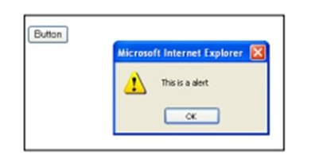

<html>
<head>
<title> Popup Message Box </title>
</head>
<body>
<button id="popupButton"> Button </button>
<script>
function displayPopup() {
alert('This is a alert');
}
document.getElementById('popupButton').addEventListener('click', displayPopup);
</script>
</body>
</html>

Exercise 02
Write a JS program to get 5 marks from the user and calculate the total and average of those marks and display the output. When a user clicks on the grade button the following should execute.
If the average is greater than 30 display an alert “Congrats! You passed” and if the average is below 30 display an alert “Better luck next time”.
<html>
<head>
<title> Calculate Grades</title>
</head>
<body>
<script>
function calculateGrade() {
var marks = [];
var sum = 0;
for (var i = 0; i < 5; i++) {
var mark = parseFloat(prompt("Enter mark " + (i + 1)));
marks.push(mark);
sum += mark;
}

var average = sum / 5;
alert("Sum is: " + sum);
alert("Average is: " + average);

if (average > 30) {
alert("Congrats! You passed.");
} else {
alert("Better luck next time.");
}
}
</script>

<button onclick="calculateGrade()"> GRADE </button>
</body>
</html>

Exercise 03
Write a JavaScript code to change the background color when the mouse pointer is moved over a button and back to normal on mouse out (Use 3 separate buttons for Red, Green and Blue colors)
<html>
<head>
<title> Change Background Color </title>
<style>
.button {
padding: 10px 20px;
font-size: 16px;
cursor: pointer;
}
</style>
</head>
<body>
<button class="button" id="redButton" onmouseover= “changeBackgroundColor('red')" onmouseout="restoreBackgroundColor()"> Red </button>
<button class="button" id="greenButton" onmouseover= "changeBackgroundColor('green')" onmouseout="restoreBackgroundColor()"> Green </button>
<button class="button" id="blueButton" onmouseover= "changeBackgroundColor('blue')" onmouseout="restoreBackgroundColor()"> Blue </button>
<script>
function changeBackgroundColor(color) {
document.body.style.backgroundColor = color;
}

function restoreBackgroundColor() {
document.body.style.backgroundColor = 'white';
}
</script>
</body>
</html>

Exercise 04
Write a JavaScript program to calculate the area of a circle, Radius should be entered through Prompt box?

<html>
<head>
<title> Calculate Circle Area </title>
</head>
<body>
<script>
var radius = parseFloat(prompt("Enter the radius of the circle:"));
var area = (22 / 7) * radius * radius;

alert("The area of the circle is: " + area.toFixed(2));
</script>
</body>
</html>

Exercise 05
Enter a number from 1-17 through a prompt box and display what day it is based on the user input.
Ex: If the user input ‘1’ output should be Monday.
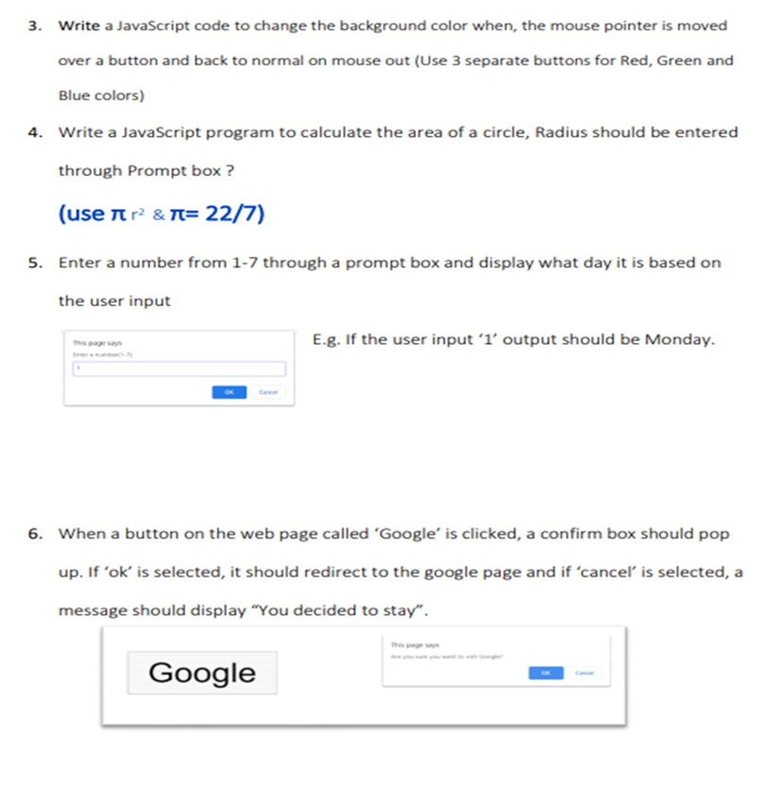
<html>
<head>
<title> Display the Day </title>
</head>
<body>
<script>
var userInput = prompt("Enter a number from 1 to 17:");
var number = parseInt(userInput);
if (number >= 1 && number <= 17) {
var daysOfWeek = [
"Monday",
"Tuesday",
"Wednesday",
"Thursday",
"Friday",
"Saturday",
"Sunday"
];
var dayIndex = (number - 1) % 7;
var day = daysOfWeek[dayIndex];
alert("The day is: " + day);
} else {
alert("Invalid input! Please enter a number from 1 to 17.");
}
</script>
</body>
</html>

Exercise 06
When a button on the web page called ‘Google’ is clicked, a confirm box should pop up. If ‘ok’ is selected, it should redirect to the google page and if ‘cancel’ is selected, a message should display “You decided to stay”.

<html>
<head>
<title> Button Click Confirmation </title>
<script>
function redirectToGoogle() {
var confirmed = confirm("Are you sure you want to go to Google?");

if (confirmed) {
window.location.href = "https://www.google.com";
} else {
alert("You decided to stay.");
}
}
</script>
</head>
<body>
<button onclick="redirectToGoogle()">Google</button>
</body>
</html>

Exercise 07
Write a JavaScript Program to perform all the Mathematical operations, The inputs should be accessed through Prompt box. (Addition, Subtraction, Multiplication, Division)
<html>
<head>
<title> Mathematical Operations </title>
</head>
<body>
<script>
function displayResult(result) {
alert("The result is: " + result);
}

function addition() {
let num1 = parseFloat(prompt("Enter the first number for addition:"));
let num2 = parseFloat(prompt("Enter the second number for addition:"));
let result = num1 + num2;
displayResult(result);
}

function subtraction() {
let num1 = parseFloat(prompt("Enter the first number for subtraction:"));
let num2 = parseFloat(prompt("Enter the second number for subtraction:"));
let result = num1 - num2;
displayResult(result);
}

function multiplication() {
let num1 = parseFloat(prompt("Enter the first number for multiplication:"));
let num2 = parseFloat(prompt("Enter the second number for multiplication:"));
let result = num1 * num2;
displayResult(result);
}

function division() {
let num1 = parseFloat(prompt("Enter the first number for division:"));
let num2 = parseFloat(prompt("Enter the second number for division:"));

if (num2 === 0) {
alert("Error: Cannot divide by zero!");
} else {
let result = num1 / num2;
displayResult(result);
}
}

function main() {
let operation = prompt("Choose the operation: Addition (+), Subtraction (-), Multiplication (*), Division (/)").trim().toLowerCase();

switch (operation) {
case 'addition':
case '+':
addition();
break;
case 'subtraction':
case '-':
subtraction();
break;
case 'multiplication':
case '*':
multiplication();
break;
case 'division':
case '/':
division();
break;
default:
alert("Invalid operation!");
}
}

main();
</script>
</body>
</html>

Exercise 08
Input Student’s NIC number and display the year of birth using String functions.
<html>
<head>
<title> Display the Year of Birth </title>
</head>
<body>
<button onclick="YearOfBirth()"> Click Here! </button>

<script>
function YearOfBirth() {
const nicNumber = prompt("Enter the Student's NIC number:");

if (nicNumber.length === 12 && nicNumber.match(/^\d+$/) !== null) {
const birthYear = nicNumber.substring(0, 4);
alert(`Year of Birth: ${birthYear}`);
} else {
alert(
"Invalid NIC number!"
);
}
}
</script>
</body>
</html>

